|  |
| --- |
| Service Guard Cluster – Existing Disk extension |
| For CATS Physical Servers |
| Recipients: |
| Remarks : |

|  |  |  |  |
| --- | --- | --- | --- |
| Version No | Date | Author | Modification Type |
| v1.0 | 13-Aug-2021 | Kiran Thomas Johnson | Document Inception |
|  |  |  |  |
|  |  |  |  |
|  |  |  |  |

Table of Contents

1 Introduction 4

1.1 Objective 4

1.2 Scope 4

2 Technical Dependency 5

3 Pre Requisites 6

4 Standard Input 7

5 Pre-Checks 8

6 Pre-Activity Log 9

7 Execution Steps 10

8 Conditional Actions 11

9 Expected Output 12

10 Post Checks 13

11 Post Check Logs 14

12 Log Comparision 15

13 Validation Report 16

14 Error Handling 17

15 Post Execution Document Update 18

16 Roll Back 19

# Introduction

## Objective

The Objective of the document is to extend the volume group or finally a filesystem which is used by a Cluster package (resource) - by extending the already used LUN and thus extending the VG and subjected LV.

## Scope

The scope of this document is only limited to CATS Physical Servers which are having HP Service Guard Cluster setup

# Technical Dependency

None

# Pre Requisites

The confirmation from requestor on the size required for extension & confirmation regarding the Lun’s – whether the existing LUN to be extended or new Lun’s to be added.

4 Standard Input

None

5 Pre-Checks

None

6 Pre-Activity Log

None

7 Execution Steps

**Extending the existing LUN:**

When there is request (RITM) for Disk extension, we will be getting the details mentioned in the attached excel saying to extend the existing LUN’s. If this is not specified, then from the Filesystem or package name, we need to find out the LUN’s required to be extended.

1. Check for # ***df -h*** output to find out the filesystem details

Eg:-

[root@slzusncsgl19 by-id]# df -h

Filesystem Size Used Avail Use% Mounted on

devtmpfs 16G 0 16G 0% /dev

tmpfs 16G 304K 16G 1% /dev/shm

tmpfs 16G 58M 16G 1% /run

tmpfs 16G 0 16G 0% /sys/fs/cgroup

/dev/mapper/vg00-root 5.8G 4.9G 667M 89% /

/dev/mapper/vg00-nmonlv 58M 8.7M 45M 17% /nmon

/dev/mapper/vg00-home 488M 888K 452M 1% /home

/dev/sda1 976M 177M 733M 20% /boot

/dev/mapper/vg00-tmp 2.0G 6.1M 1.8G 1% /tmp

/dev/mapper/vg01-data 7.1G 151M 6.6G 3% /data

/dev/mapper/vg00-opt 2.9G 582M 2.2G 21% /opt

/dev/mapper/vg00-var 3.9G 2.2G 1.5G 61% /var

tmpfs 5.0M 0 5.0M 0% /var/cache/salt/minion/proc

/dev/mapper/vg_ZUS10_Donnees-lv_zus10--data 6.8G 142M 6.3G 3% **/MYS/ZUS10/Donnees/MYS**

/dev/mapper/vg_ZUS10_Procparm-lv_zus10--proc 6.8G 32M 6.4G 1% **/MYS/ZUS10/Procparm/MYS**

tmpfs 3.2G 0 3.2G 0% /run/user/0

/dev/mapper/vg_ZUS11_Exports-lv_zus11--data 6.8G 32M 6.4G 1% /data/ZUS11/Donnees/NFS

Here in the example, the Filesystems belonging to ZUS10 package - “/MYS/ZUS10/Donnees/MYS & /MYS/ZUS10/Procparm/MYS needs to be extended.

1. The respective PV’s need to find out with # ***pvs*** command.
2. Once the corresponding md devices are found , its array devices (dm’s) can be found out with

# ***mdadm -D </dev/md#>*** command

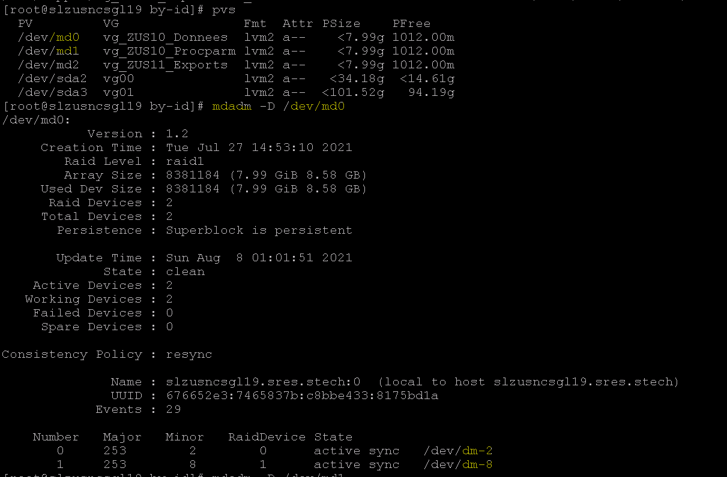

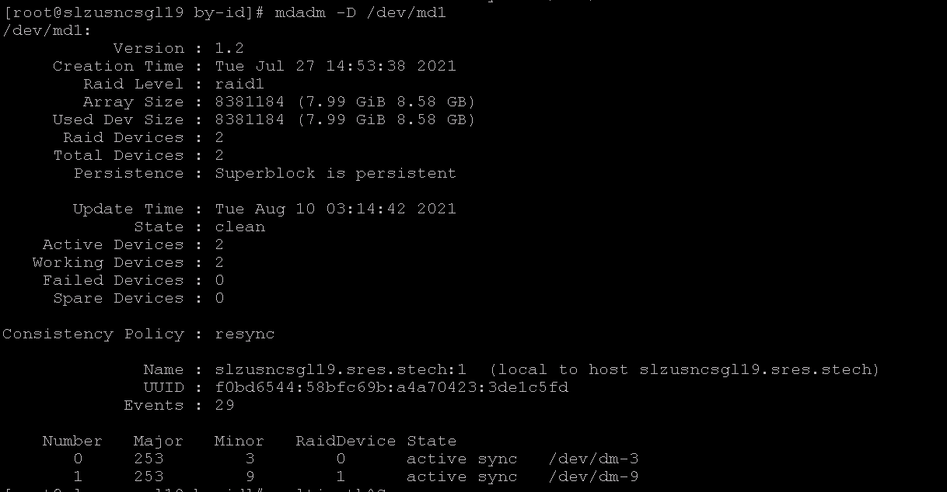

Quick summary:-

Requirement is for extending - “/MYS/ZUS10/Donnees/MYS & /MYS/ZUS10/Procparm/MYS”

PV’s used for these FS’s are - md0 & md1

Array disks used in these md’s - {dm-2 + dm-8} for md0 & {dm-3 + dm-9} for md1

Finding out the LUN’s:-

Once the dm’s are found from mdadm details (***mdadm -D***), the LUN’s can be find out from multipath command as shown below:

# ***multipath -ll |grep <dm-device>***

***eg:- multipath –ll |grep dm-2 -A4***

***NB:- If more than 2 paths are available, then it’s better to not grep for 4 line, rather to check the entire paths with:***

***# multipath -ll <mpath device>***

***eg:- multipath -ll mpathA01***

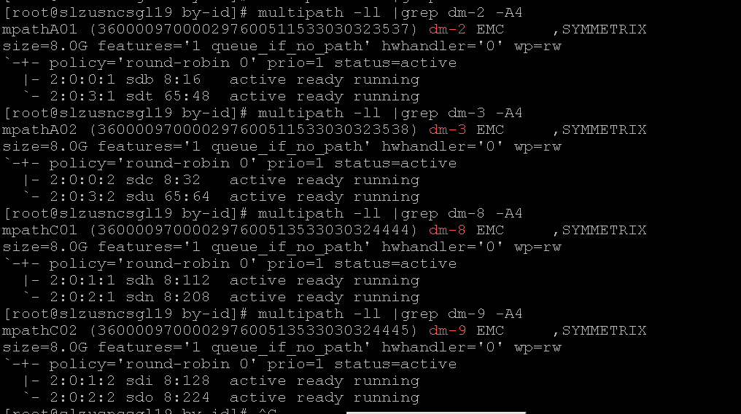

In our case, these are 4 responsible LUN’s –

360000970000297600**511**533030323**537**, 360000970000297600**511**533030323**538**, 360000970000297600**513**533030324**444** & 360000970000297600**513**533030324**445**

of 8 GB each (physically located in our main 2 DC’s - DID & DAL for redundancy. We can see the LUN WWN’s having 511 & 513 in the middle of the number as highlighted and thus we are creating Alias name in /etc/multipath.conf accordingly, and in our case as we can see 511’s are named as mpathA and 513’s are named as mpathC) comprising the raid devices which in turn are used for our PV and VG from which we have created the subjected Filesystems.

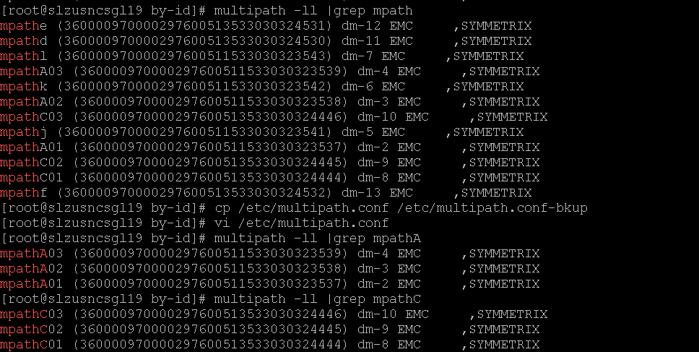

Once these details are provided to SAN Storage team (Stockage), they will extend these 4 LUN’s as per new requirement and we have to rescan and reload the multipath services to get the new size reflected at our end.

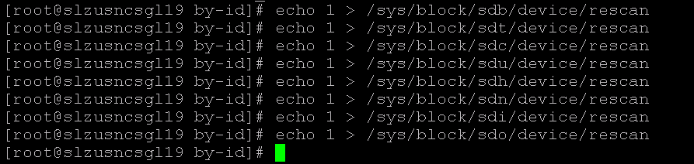

The block devices – sdb, sdt, sdc, sdu, sdh, sdn, sdi & sdo can be seen in the multipath output for each dm device.

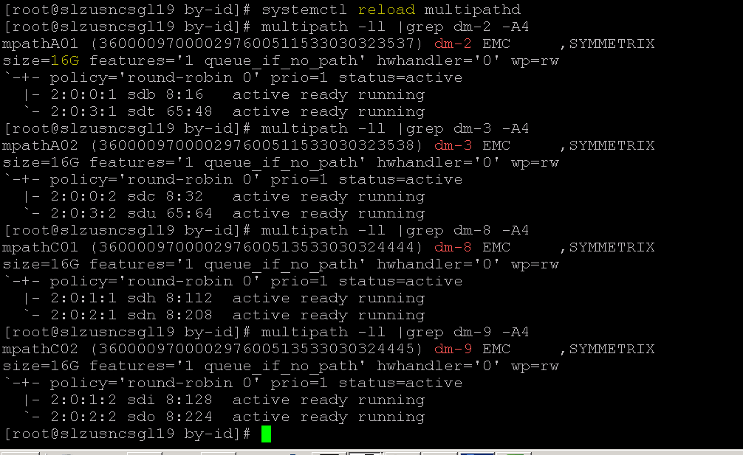

*NB: - If the size is not reflecting even after multipath reload, try resizing the mpath device manually with the command:*

# ***multipathd resize map <mpath device>***

*eg:-* multipathd resize map mpathD02

***The below 2 screens are for representation purpose and not for the Server which the document discusses****.*

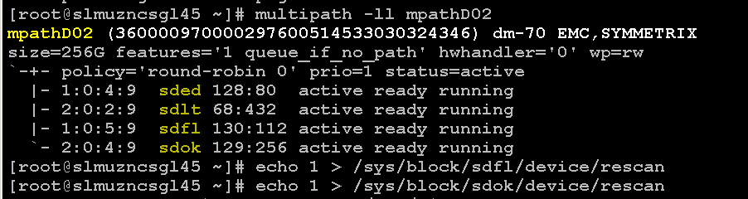

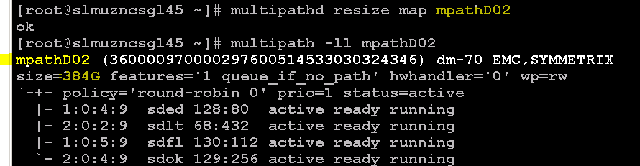

Once the resize and reload are done, we can see the new size as given above (here in our case it is 16 GB).

Now we are good to proceed further for VG or LV extension steps.

**Steps in short:-**

1. Stop the cluster package(s) as required
2. Activate the mdraid devices
3. Add tags to the respective VG’s
4. Activate the VG’s to be extended
5. Extend the disks at md level
6. PV resize
7. Filesystem check
8. VG extend
9. LV extend
10. FSCK again for sanity check
11. Deactivate VG’s
12. Delete tags in VG’s
13. Stop mdraid devices
14. Start the cluster packages.

**Stop package:**

# ***cmhatlpkg <pkg name>***

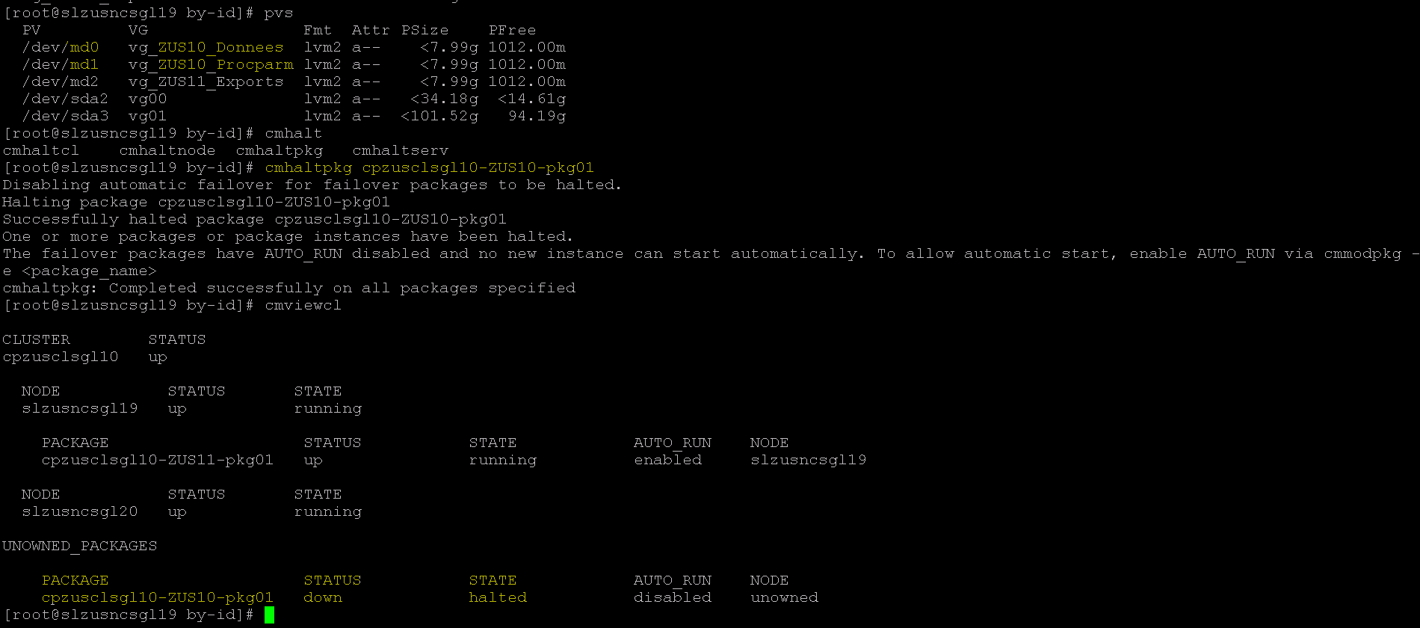

We can see that the package is halted now by checking with command # ***cmviewcl***

If we see “STATE” =”halted”, then we can conclude that the package is

**Activate the Raid device:**

# ***mdadm –A –R </dev/mdX>***

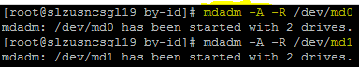

**Adding Tags & Activating the VG:**

# ***vgchange -- addtag `hostname` <vg name>***

# ***vgchange -- ay <vg name>***

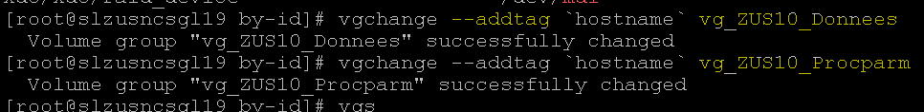

We can see the tags associated to a VG with the command:

# ***vgs -o +tags***

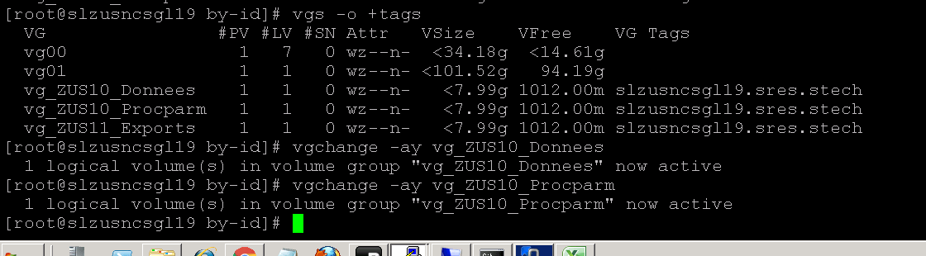

**Mdadm grow for new space addition:**

# ***mdadm --grow <md device> --size=max***

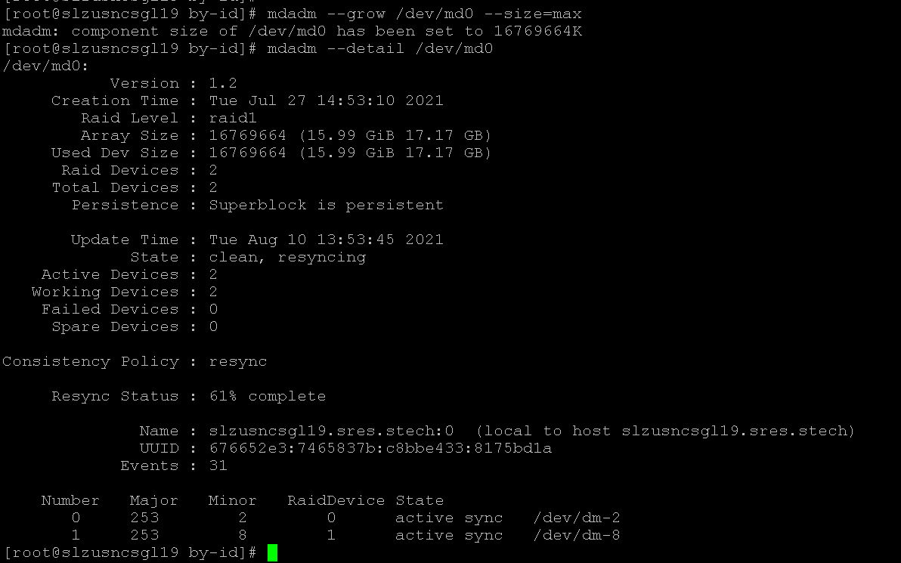

We can see the “Resync Status” (percentage completion) in the above screenshot and it will take some time (depending on the size of the disk) to get it fully synced and we can see the new size finally as below:

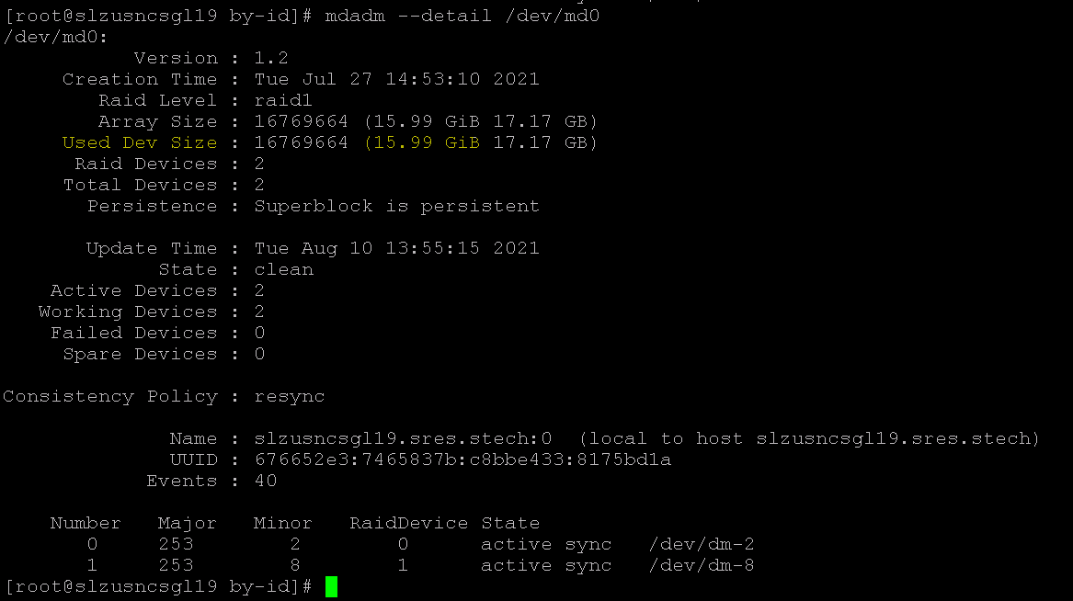

**PV resizing:**

**# *pvresize </dev/mdX>***

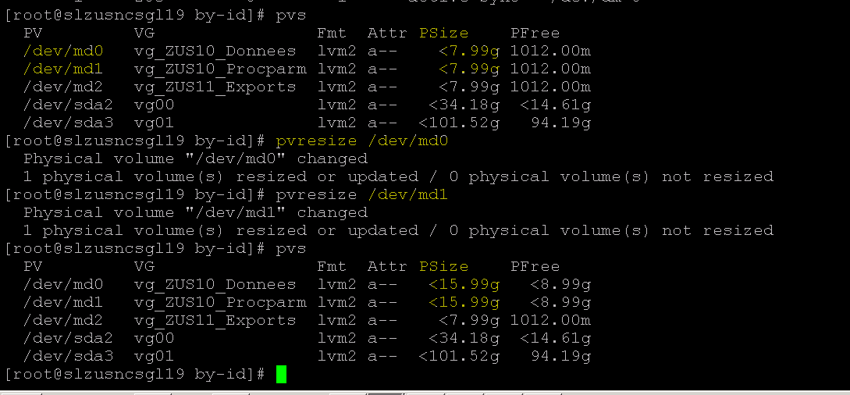

**Filesystem Checking:**

# ***e2fsck -f /dev/mapper/<vg name-lv name>***

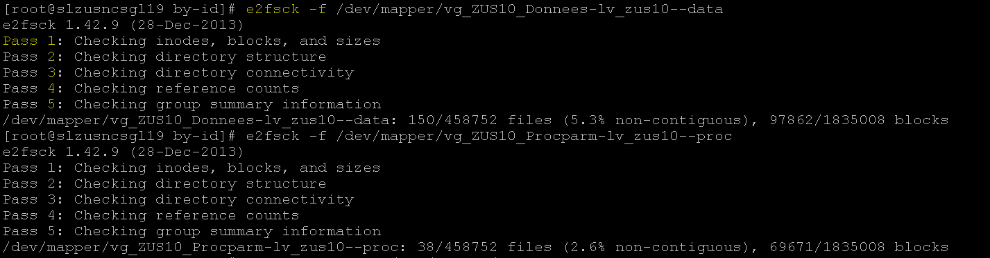

NB: - All 5 Tests should pass to proceed further.

**LV extension:**

# ***lvextend -L +8G /dev/mapper/<vg-lvname> -r***

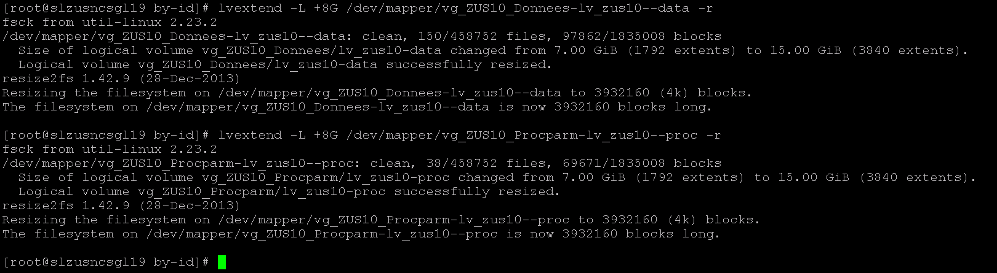

**Filesystem Checking again for sanity, VG Deactivation, VG Untag:**

***#*** ***e2fsck -f /dev/mapper/<vg-lvname>***

***# vgchange -an <vg name>***

***# vhcgange --deltag `hostname` <vg name>***

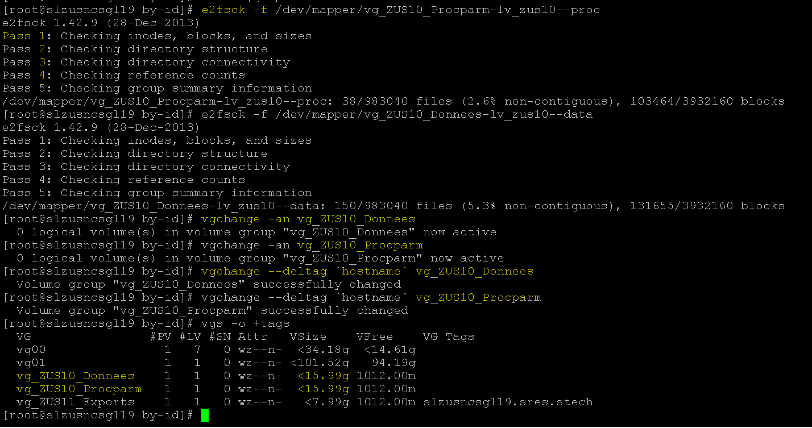

**Stop mdadm device:**

**# *mdadm -S /dev<md#>***

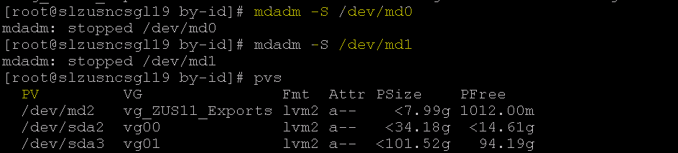

**Starting package & enabling it:**

**# cmrunpkg <pkg name> -n <node name>**

**# cmmodpkg -e <pkg name>**

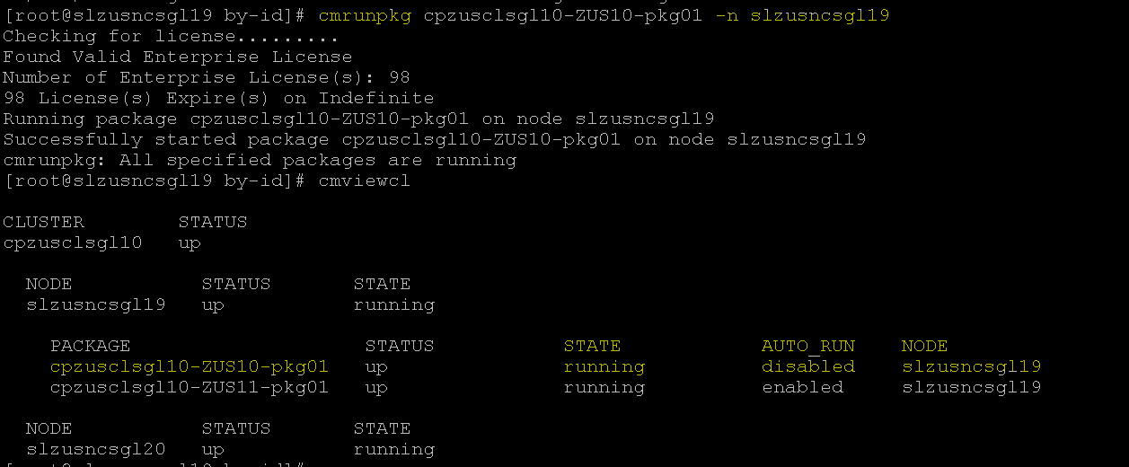

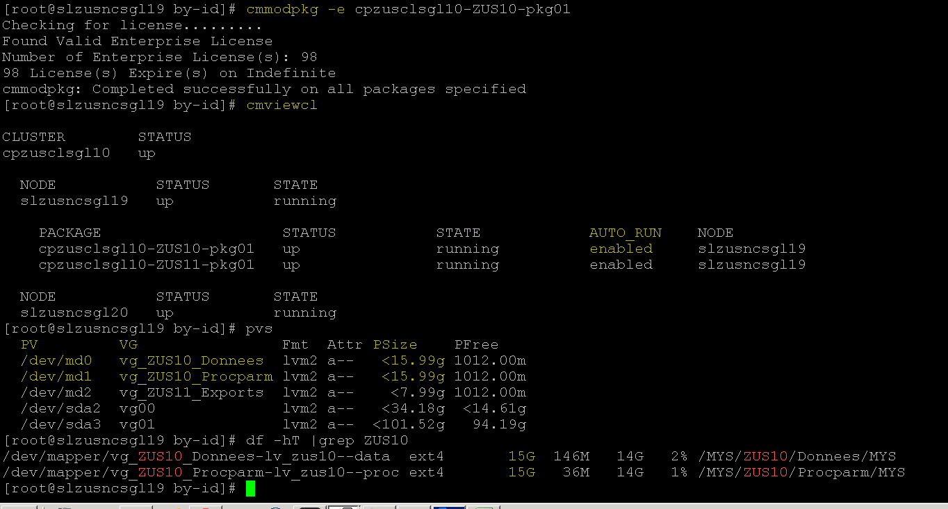

Once packages are back into running (& enabled) state, we can check the FS size with # ***df -h*** command

Now we can see the extended Disk size reflected in the FS finally.

8 Conditional Actions

None

9 Expected Output

None

10 Post Checks

None

11 Post Check Logs

None

12 Log Comparision

None

13 Validation Report

None

14 Error Handling

None

15 Post Execution Document Update

None

16 Roll Back

None